**Small notes of activities template (for reference):**

Parents could feel free to adjust the content of the notes, or add other items in the blank box as needed.

|  |  |
| --- | --- |
| **2 Pages**  **Summer**  **Homework** |  |
| **Online**  **Exercise** |  |
| **1 Reading Comprehension** |  |
| **1 News**  **Reading** |  |
| **2 Pages**  **Exercise** |  |

**Study**

**Exercise**

|  |  |
| --- | --- |
| **Running** |  |
| **Stretching** |  |
| **Skipping** |  |
| **Swimming** |  |
| **Hiking** |  |
| **Cycling** |  |

|  |  |
| --- | --- |
| **Play with**  **toys** |  |
| **Have Fun in**  **Community Hall** |  |
| **Watch**  **Television** |  |
| **Painting** |  |
| **Have Fun in**  **Park** |  |
| **Take a**  **nap** |  |

**Leisure activities**

**Family time activities**

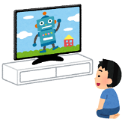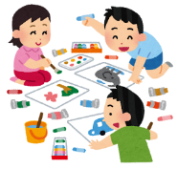

|  |  |
| --- | --- |
| **Go out with parents** |  |
| **Chat with**  **parents** |  |
| **Walk with**  **parents** |  |
| **Story**  **time** |  |
| **Cook with**  **parents** |  |
| **Volunteer**  **with parents** |  |