

11.

1

Control Plan

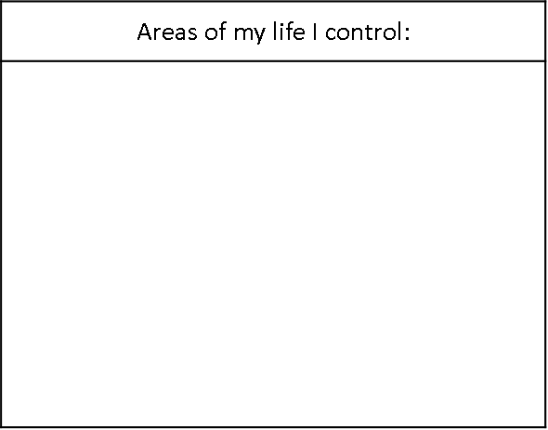









**How do I do this:**



**Or…**

**How can other people help me?**

**How will I do this?**

**Something new I would like to try to control about my life is:**