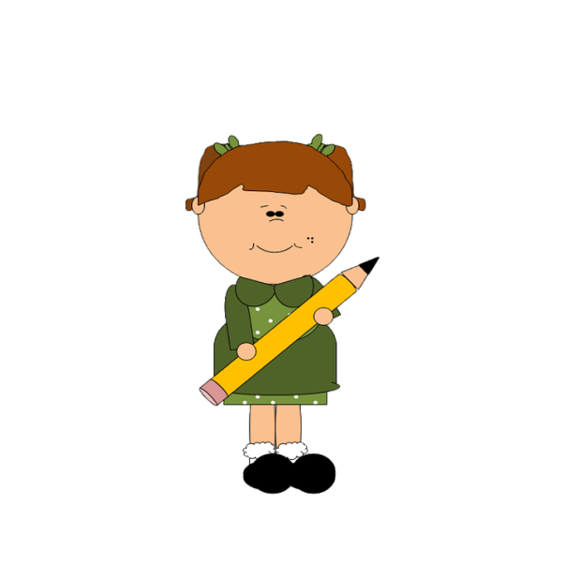
11.
6
My homework and me:
My Homework and Me

 | I must: | I will use these things to help me | When I have finished I will: | Homework hand-in day:
Monday
Tuesday
Wednesday
Thursday
Friday
Saturday / Sunday

