

12.

3

SENCO Role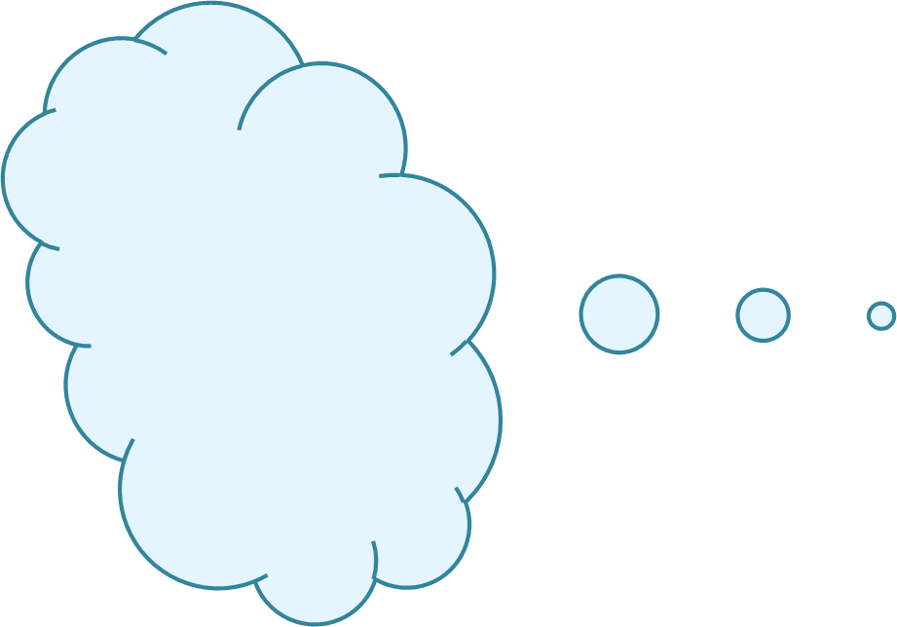

What I hope to achieve from my communication with the SENCO:

Important things the SENCO needs to know to help with our communication:



SENCO Role

I think a SENCO can:

I think a SENCO can’t: