

15.

2

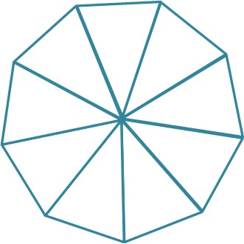This Is Me

SpLD

ID

ASD

AD/HD

PD

VI

HI

SLI

SEMH/MI

For me this means

I have:

I am good at:

You can be my friend by:

This is me:

I am clever in these ways:

I am interested in: