

4.

1

Iceberg (Template)

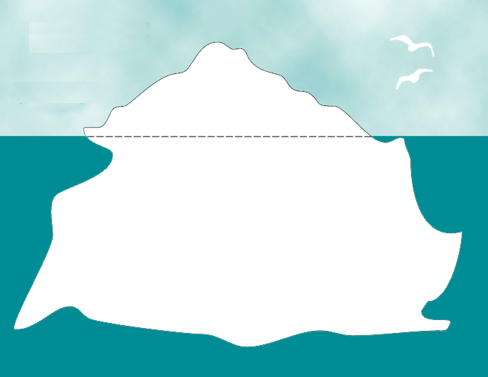

**What teacher’s say**

Problems on the surface

What SENCO’s ask

Iceberg (Example)

1

4.



Problems on the surface

* Writes only a few lines.
* Forgets what to do.
* Untidy, illegible writing.

What SENCO’s ask

**What teacher’s say**

* Short term memory difficulties?
* Organisation and sequencing difficulties?
* Language processing difficulties?
* Difficulty recalling a sentence then words within the sentence then spellings within the words?
* Poor fine motor skills?
* Limited vocabulary knowledge?
* Fear of failing?
* Task avoidance.
* Reluctance to write.
* Difficulty accepting praise.
* Chats and distracts others.