

5.

1

一頁檔案 One Page Profile (Template)

一頁檔案 One Page Profile (Example)

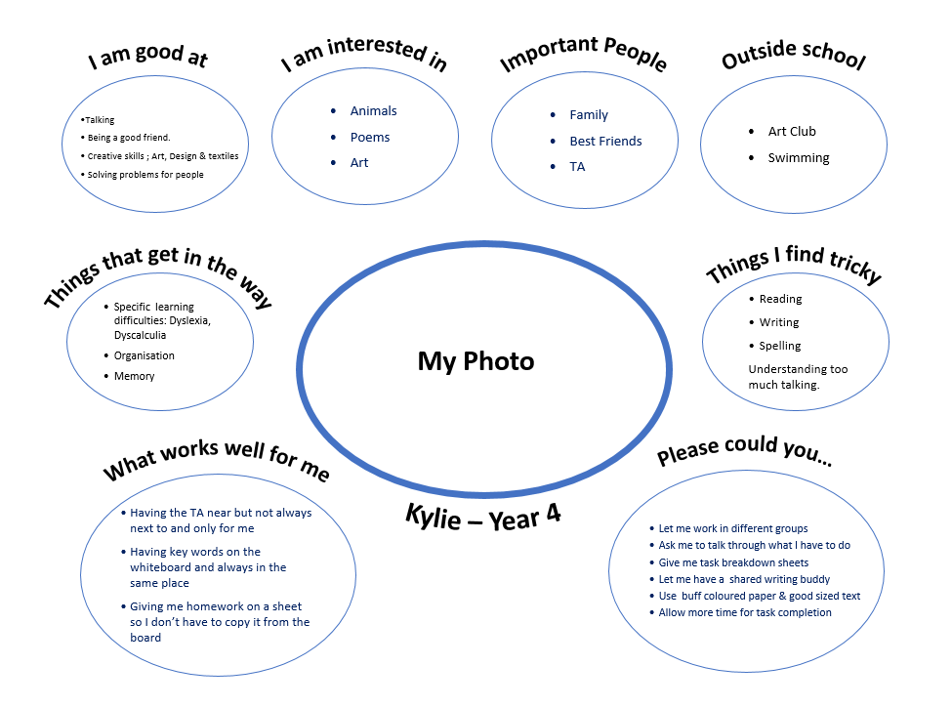

* Understanding too much talking



5.

1