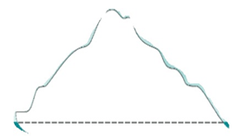Icebergs and Jigsaws

What do others say?

What does the pupil say?

What do you see? Teacher

7.

7

What has been tried?

What has been tried?

What works?

Pupil

Name:

Class:

Year:

Attainments:

Other:

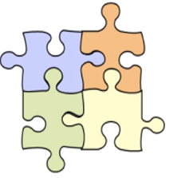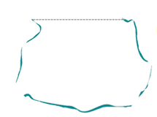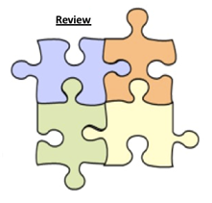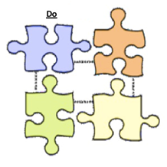

What more do you want to know?

What could be going on under the surface?

=

Repeat the cycle

**Plan** (you can have as many pieces as you want)

Question?